**Important!**

-The images do not reflect the correct scale of the characters. While all of them can jump, the gaps present are too big for all of them.

- Blue parts are in the background, meaning the characters can go through them.

- All characters CAN NOT swim!

**Idea #01 (Mid/Late-Game)**

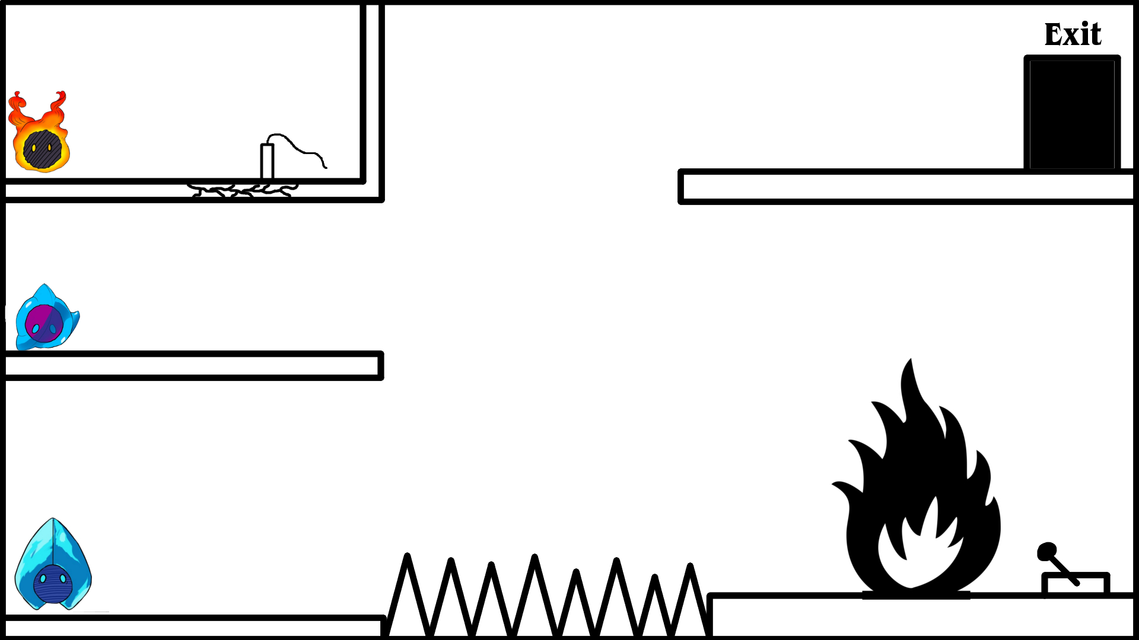

**Solution**

1. Position Depression to the right of the cracked wall. Otherwise, Rage will run into the spikes.
2. Switch to Rage and activate its ability to light the dynamite. Make sure to start his ability so that he isn't near the dynamite once it explodes.
3. Switch to Anxiety and jump onto the spikes.
4. Activate Anxiety's ability mid-air, causing it to freeze up and land on the spikes.
5. Switch to Depression and jump onto Anxiety over to the lower right side.
6. Activate Depression's ability and put out the fire with its tears.
7. Switch to Rage and bring him over to Depression in order to regain control over both.
8. Activate the switch on the right in order to make the spikes retract into the ground and a staircase up to the second floor on the left appear.
9. Move both Depression and Rage back up the Staircase, collecting Anxiety in the process
10. Using Rage's & Depression's combination, create a staircase out of magma from the second floor to the floor with the exit, being careful that Rage will be able to run into Anxiety afterwards.
11. Move all characters to the exit.

Idea #02 (Late-Game)

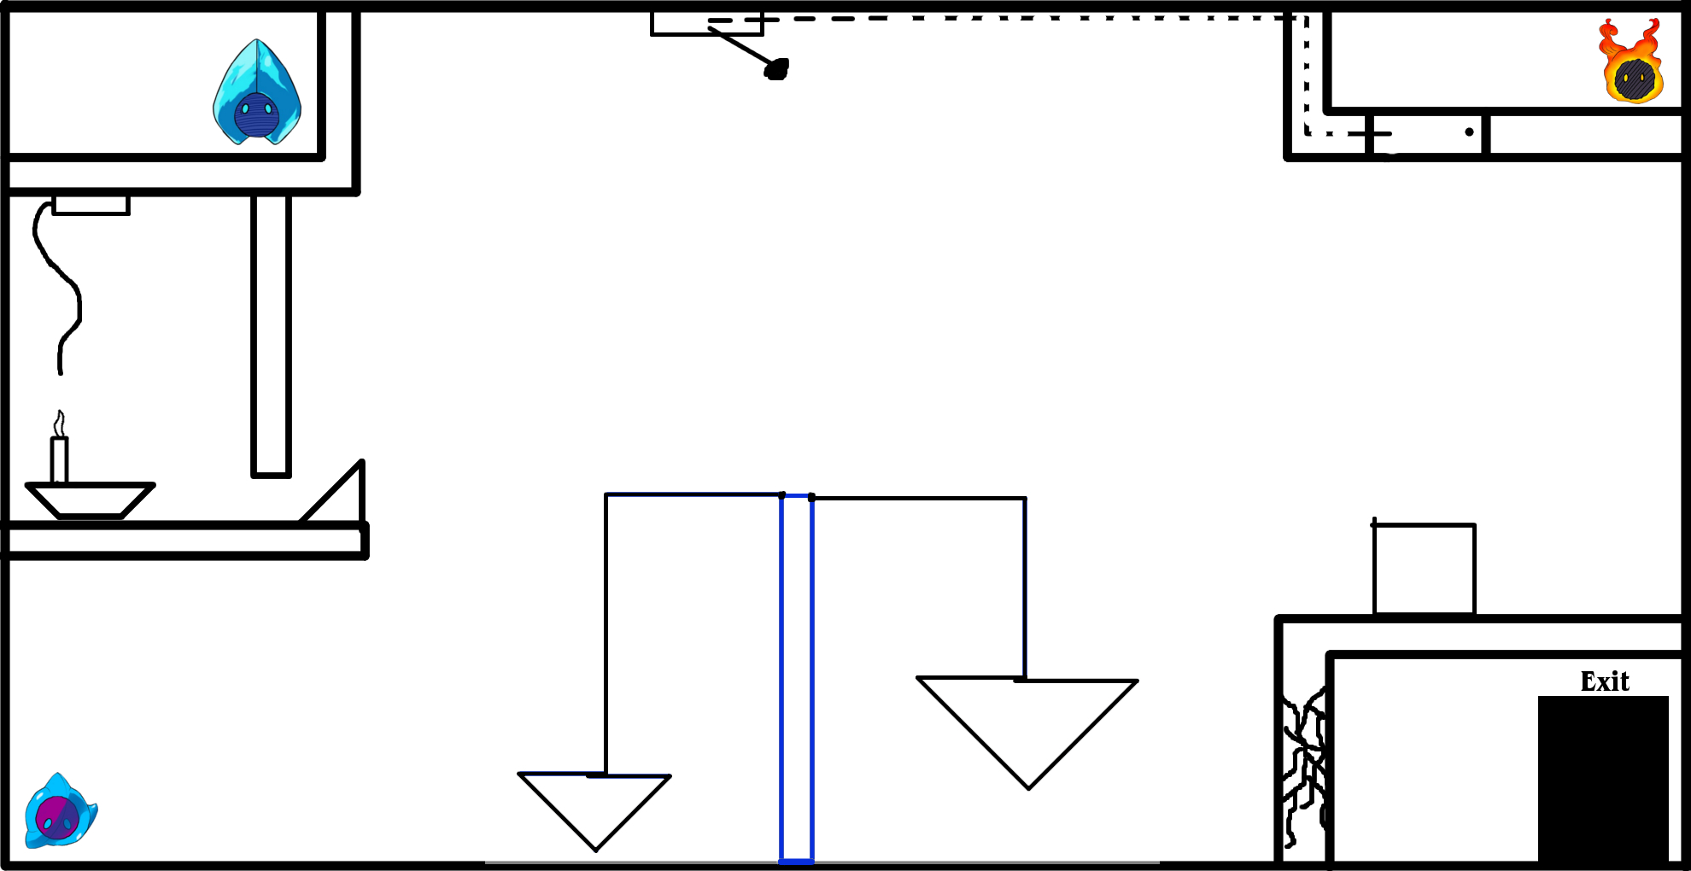

**Solution:**

1. Use Depression to jump up the scale and behind the box.
2. Push the box onto the scale to make it tip
3. Jump to the left just above the little slope
4. Activate Depression's Ability and fill the room with the candle with tears
5. The candle floats up and activates the dynamite, freeing Anxiety.
6. Move Anxiety over to Depression to regain control over both
7. Combine Depression and Anxiety in order to shoot the lever at the top, freeing Rage.
8. Drop down with Rage and meet up with the other two.
9. Activate Rage's ability to break through the wall blocking the exit.
10. Move everyone to the exit.

Idea #03 (Introduction to Rage & Anx. Fusion)

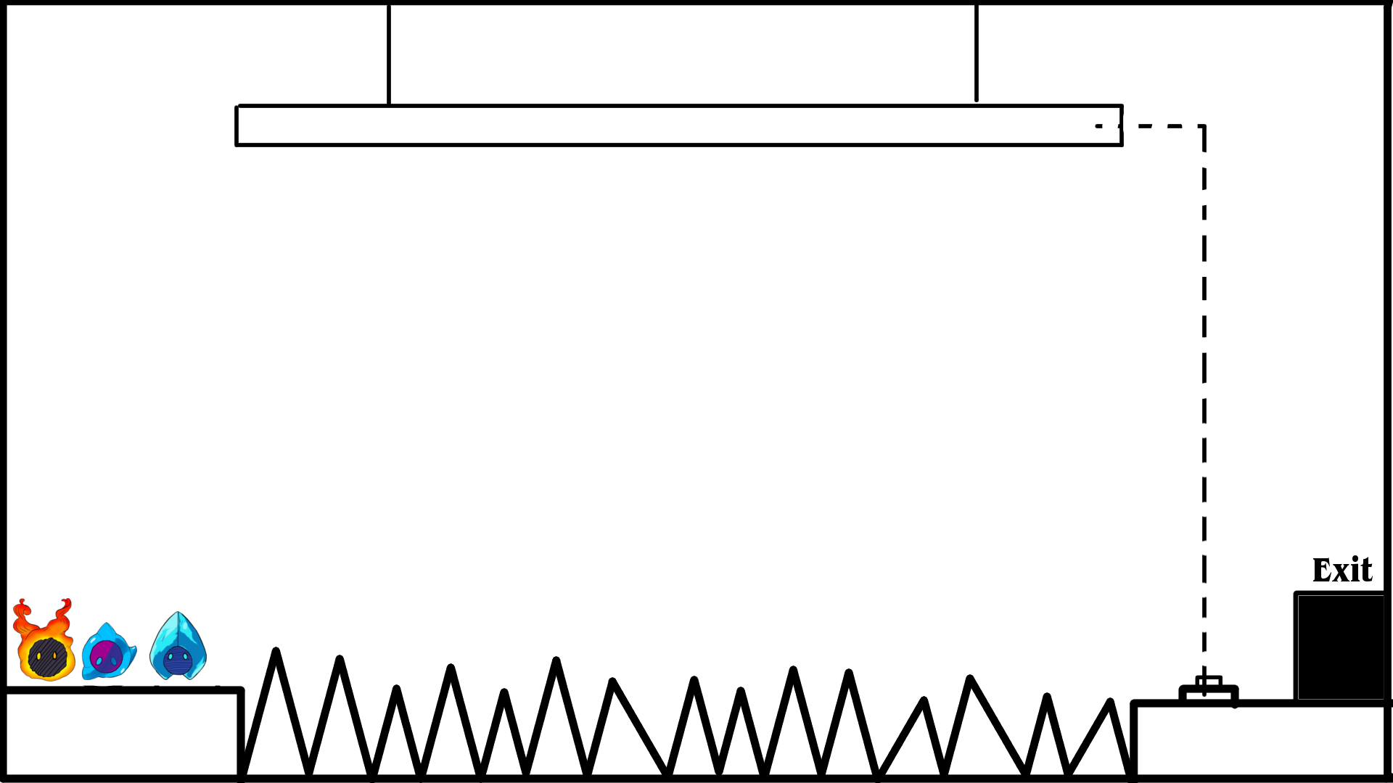

**Solution:**

1. Rage and Anxiety Fuse together and run over the spikes.
2. They activate the button, causing the platform at the top to fall down
3. Depression can follow them and all can finish the level

Idea #04 (Late-Game)

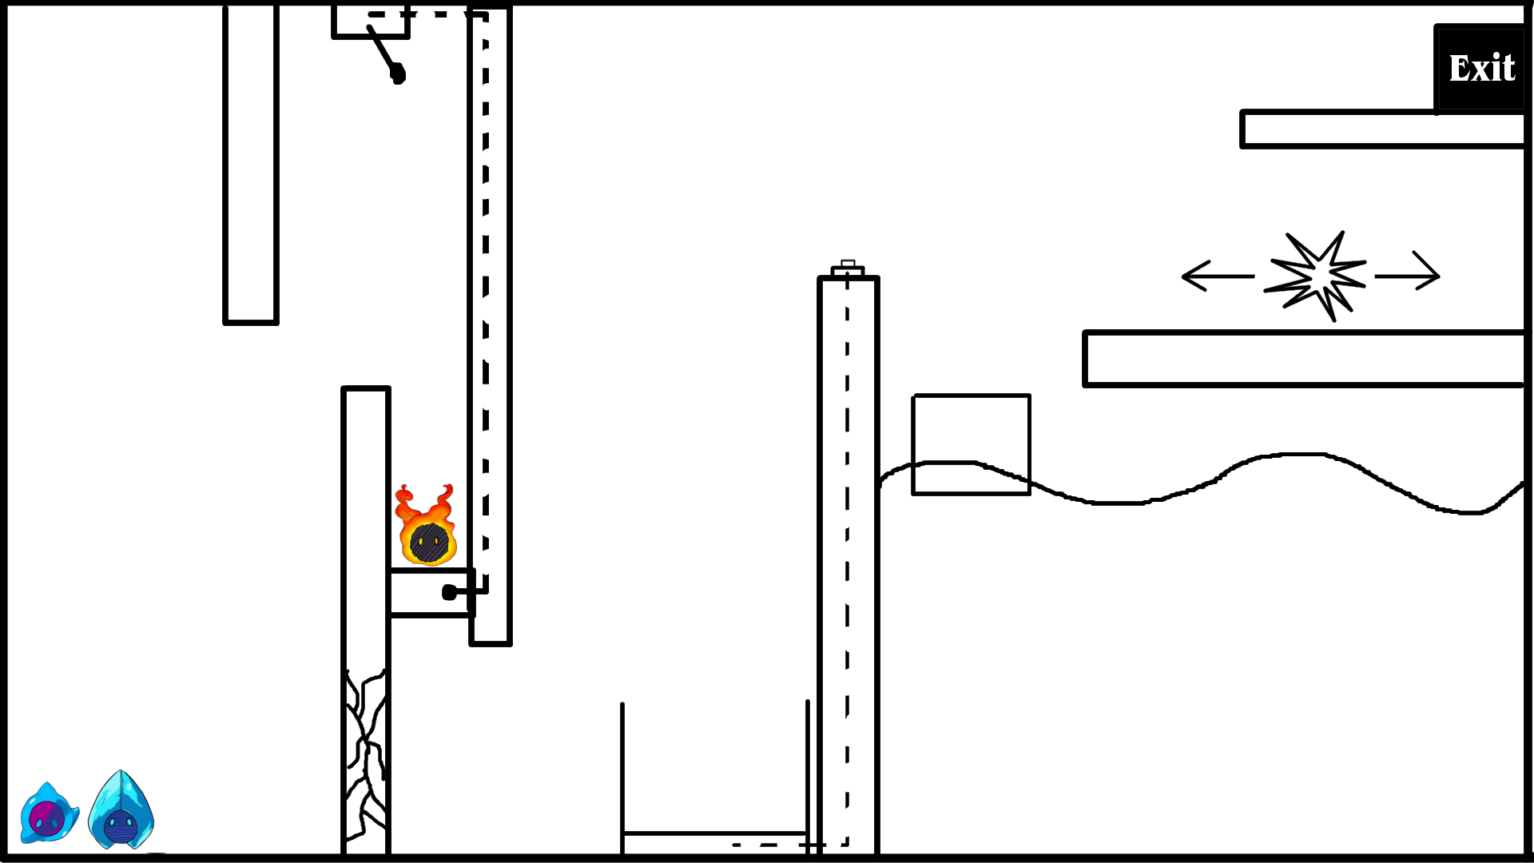

**Solution:**

1. Depression and Anxiety Fuse together and shoot the top switch with frozen tears, freeing Rage.
2. Rage activates his ability to break through the wall, causing all of them to meet up again.
3. Position all 3 characters on the elevator in the middle
4. Using Despressions ability, blast it onto the button at the top.
5. The elevator moves up, reuniting all of them.
6. Use “Cold Feet” to trap the enemy to the right.
7. Position Depression so that once his ability activates, its tears raise the water level below, bringing the box up.
8. Using the Box, bring all characters to the exit.

Idea #05 (Introduction to "Eruption")

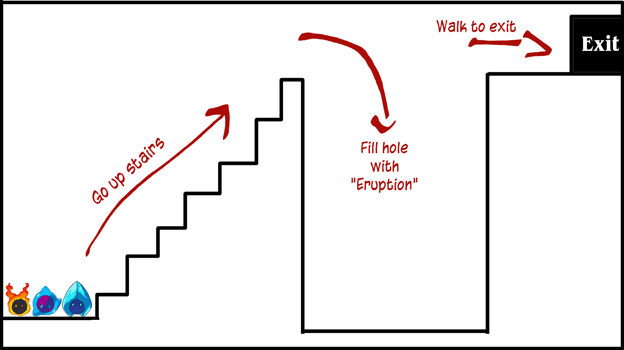

**Solution:**

1. Position all 3 characters at the top of the stairs
2. Combine Rage and Depression to use "Eruption and fill the hole with magma.
3. Collect the two with Anxiety
4. Move to the exit.

Idea #06 (Introduction to Anxiety)

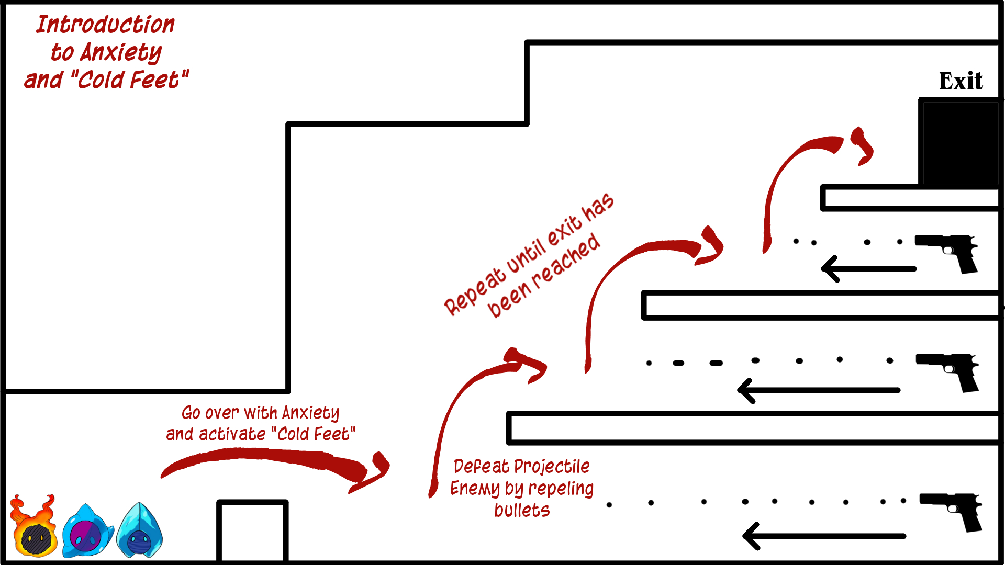

**Solution:**

1. Jump over the safety wall with Anxiety when no the projectile is not on screen
2. Activate "Cold Feet" and wait for next projectile
3. Projectile will be reflected to source and defeat source
4. Bring Rage and Depression to regain control over Anxiety
5. Repeat process for the nest 2 steps
6. Bring all characters to the exit.

Idea #07 (Introduction to Depression)

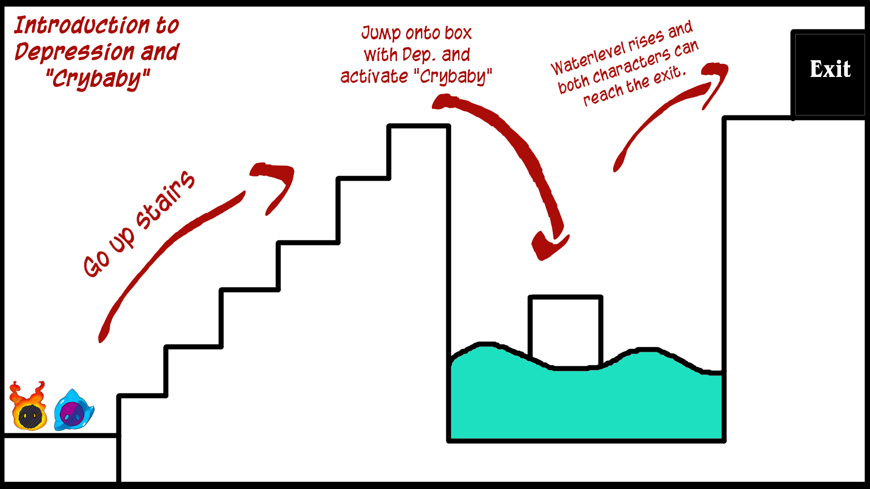

**Solution:**

1. Move both characters up the stairs
2. Jump onto the floating box with Depression
3. Use "Crybaby" and direct the tears onto the water.
4. After the water level has risen, let Rage meet up with Depression
5. Move both characters to the exit.

Idea #08 (Intended as first level)

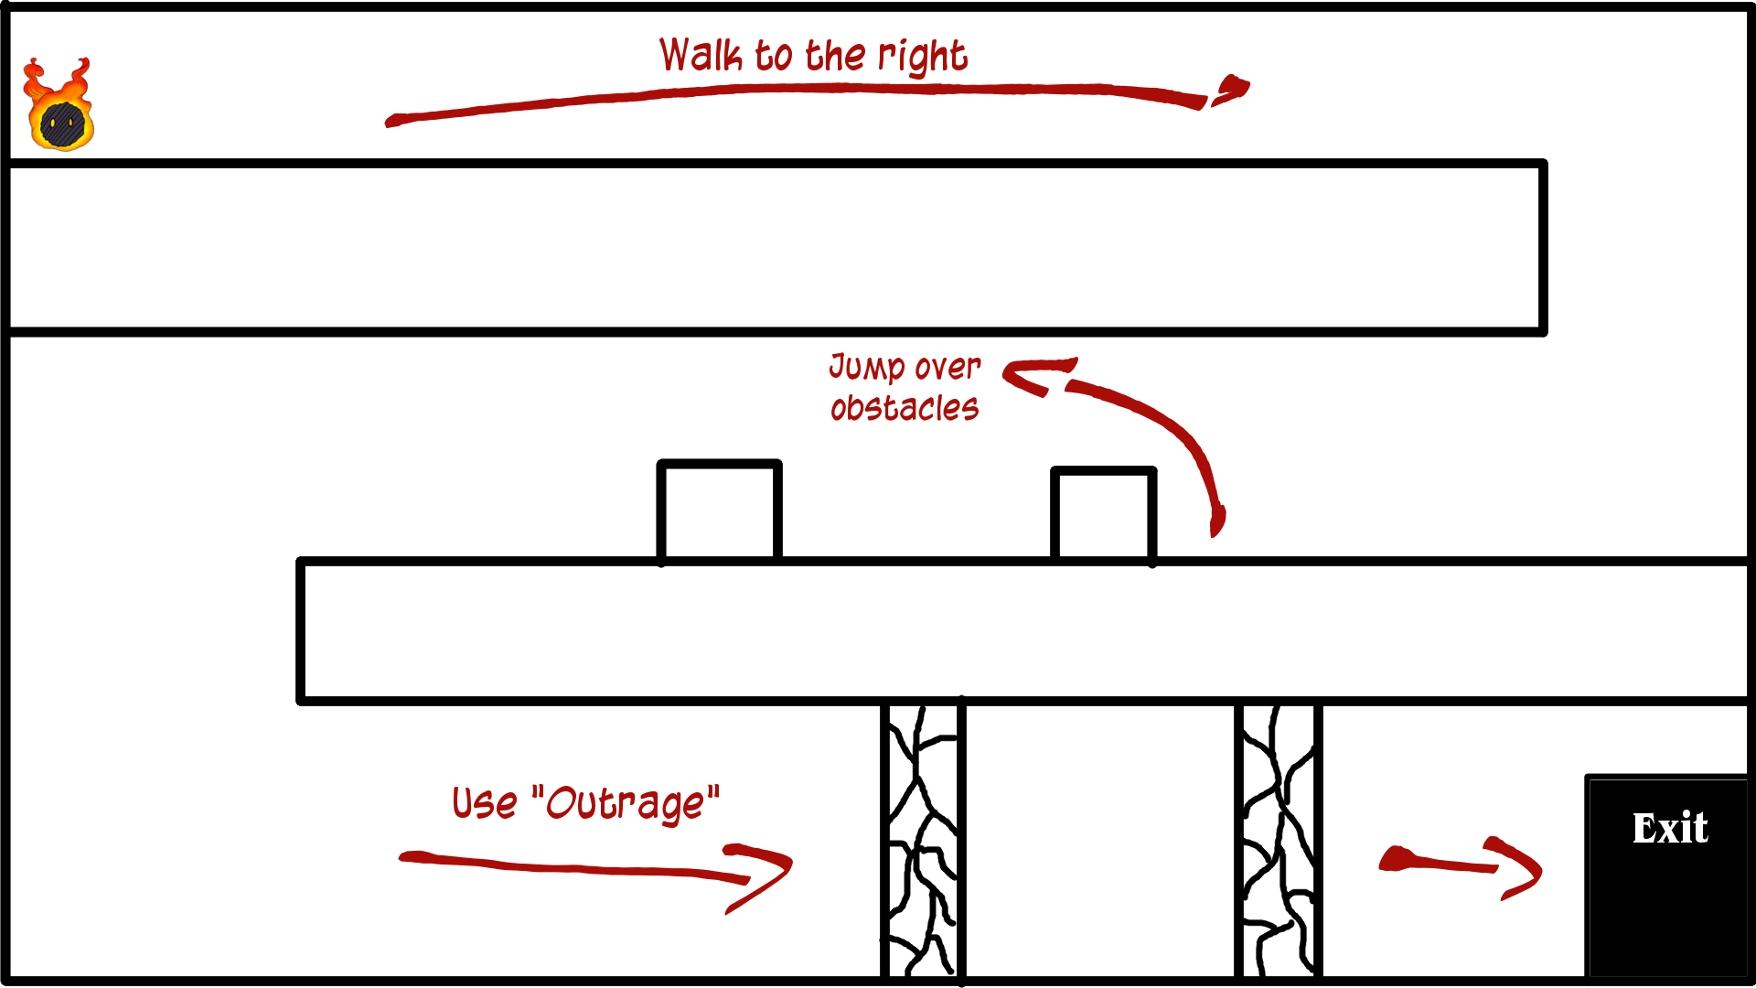

**Solution:**

1. Walk to the right and drop down
2. Walk left and jump over the obstacles
3. Walk right again and activate "Rampage"
4. Rage will move to the exit automatically

Idea #09 (Intended as Level 2)

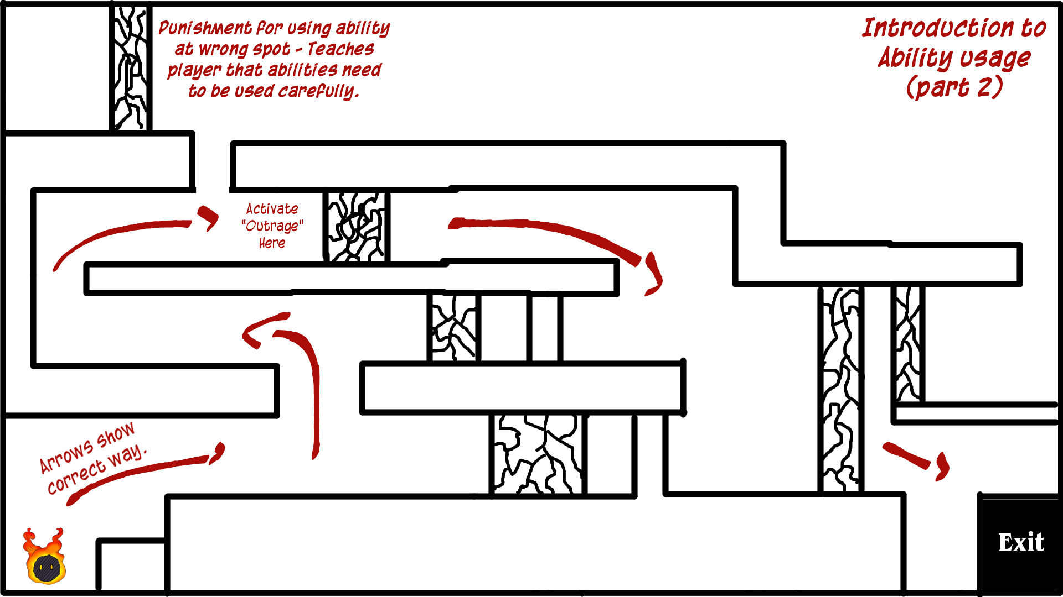

Solution:

1. Jump up at the first hole and turn left.
2. Jump up again and activate “Rampage” while facing right.
3. Rage dashes towards the exit automatically.

Idea #10

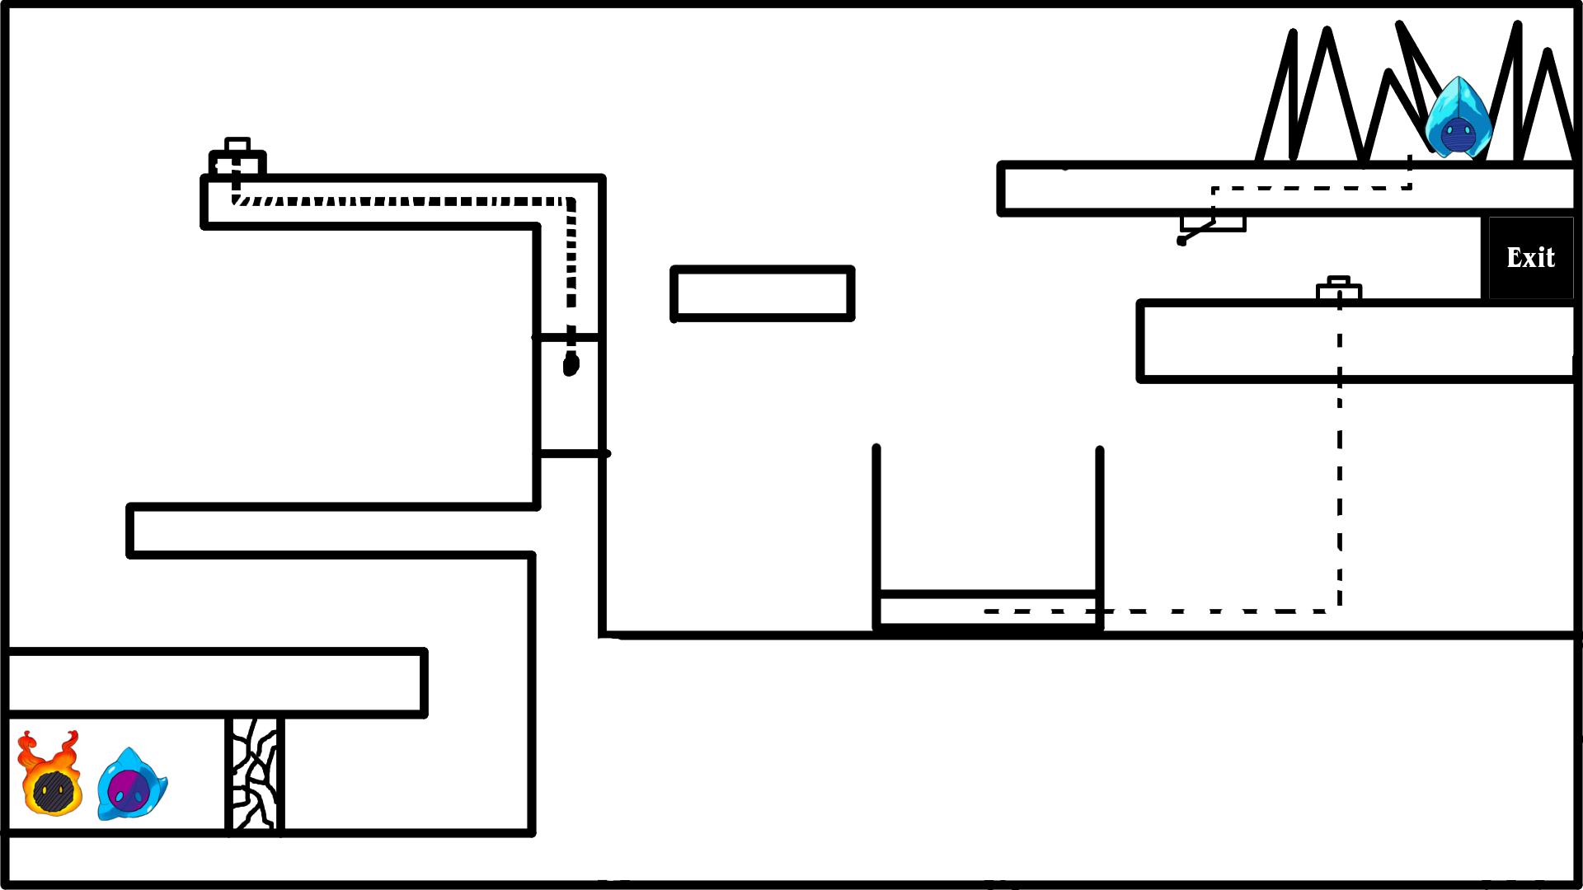

**Solution:**

1. Break the wall with "Outrage"
2. Jump up onto the ledge.
3. Use "Crybaby" to jet back onto the button.
4. The door opens. Walk through it and collect Depression.
5. Use "Crybaby" to propel Depression into the level near the exit, releasing Anxiety.
6. Collect Anxiety with Rage and position both on the elevator
7. Activate "Cold Feet" to make a platform for Rage.
8. Jump onto the ledge, collecting Depression in the process, and step on the bottom, raising the elevator
9. Collect Anxiety with Depression and move all characters to the exit.

Idea #11

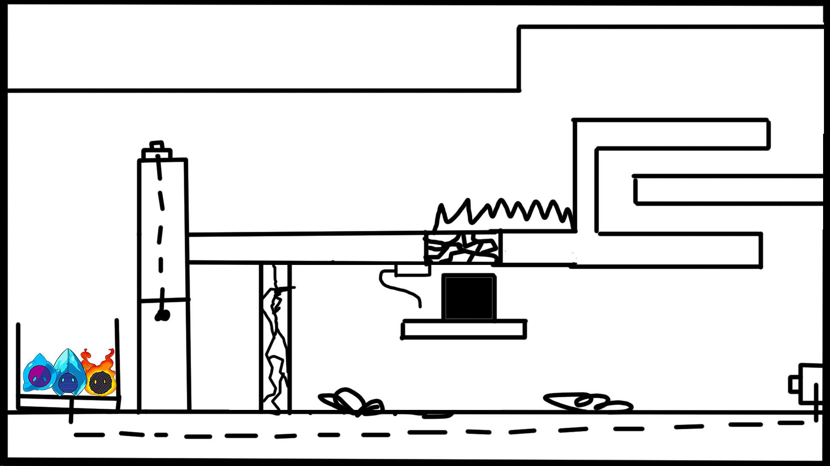

**Solution:**

1. Use “Crybaby” to activate the button on top of the wall.
2. Use “Rampage” to break through the wall and activate the button. This will both raise the elevator and make the flammable objects catch fire, blocking the way.
3. Collect Depression with Anxiety and move both to the right.
4. Jump onto the spikes with Anxiety and Activate “Cold Feet”. Make sure he falls above the cracked wall.
5. Using Anxiety as a platform, jump onto the right side with Depression until you reach Rage.
6. Put out the Fires with “Crybaby”.
7. Activate the Dynamite with “Rampage” after calming Depression down. Anxiety falls down onto the exit.
8. Calm Rage down with Depression and move all characters to the exit.

Idea #12

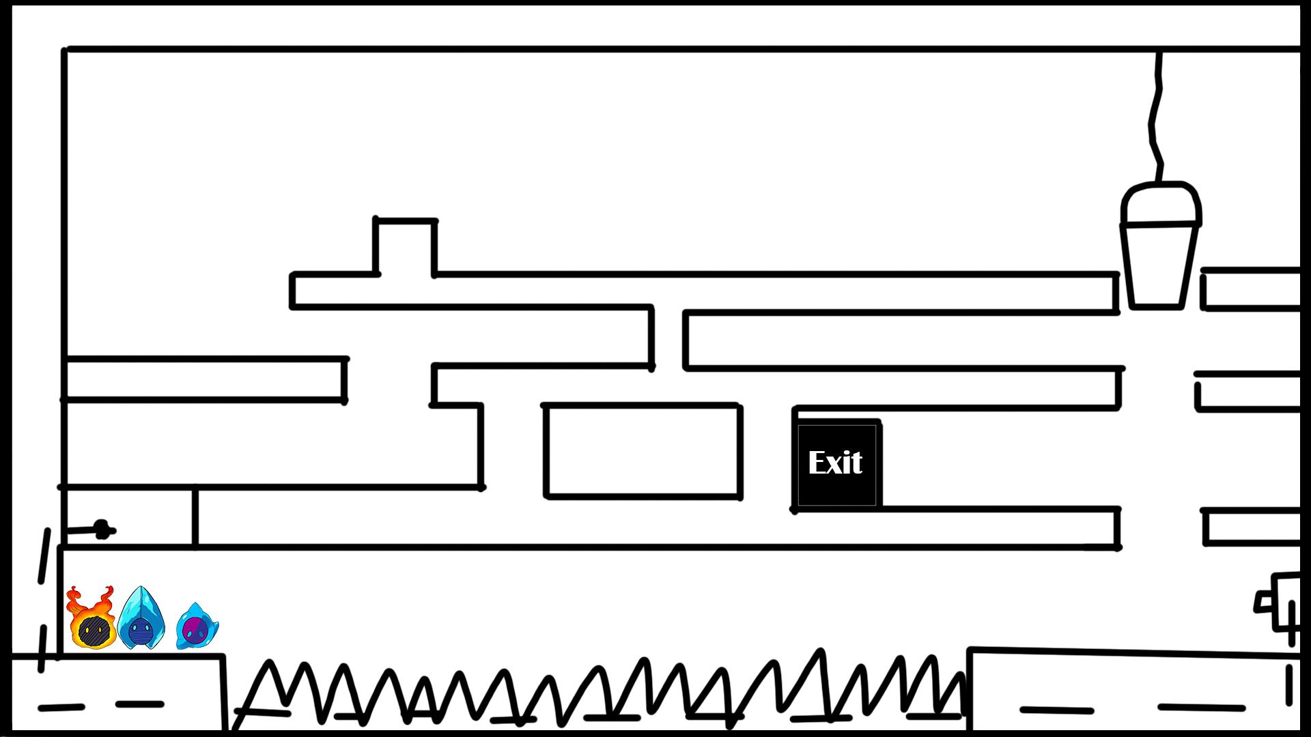

Solution:

1. Use “Frozen Outrage” to run over the spikes and hit the button, opening the way for Depression.
2. Go through the maze with Depression. (Maybe put some enemies here that need to be evaded)
3. Jump into the bucket and activate “Crybaby”, causing the button to sink and all characters to meet up.
4. Move the characters to the exit.